**PraGroupTest Deployment GuideNotes**

1. The application is developed concentrating on IOC using unity and Hexagonal architecture.
2. Currently application is set to read data from XML repository. This can be changed to read from SQL or Tera or may something else if decided later. Similarly a data source can be some test env (sql or excel or may be text file). These can be configured provided the code is written for these services.
3. Currently implemented 5 state tax classes (IL [5%tax], OH [5%] , IN [7% just for demo], TX[0%], FL[0%]).. more class implementation can be added and the same must be configured in state xml files.
4. Both widget and state objects are read from C:\PraGroupTest\XMLData\. This can be configured to read from config files.. but for demo- hardcoded currently. So you need to create above said folder and paste xml files into that.
5. Please note – The unit tests are not created yet. I spent considerable amount of time on this, and want to have my week end. I can work on them if you want to take a look on how I would do them.
6. As mentioned above, concentrated on IOC and Hexagonal architecture.. So

* Not implemented exception handling
  + So user is shown error as is on the screen.
* Not implemented logging
* Not implemented validation of data from source, So..
  + data in xml files must be accurate
  + If you don’t provide baseprice, or indicator they will be defaulted to “0” and “false”.
  + The right TaxCalculationdll must be provided in States.xml. Otherwise application throws error.
  + So Rerun the application adjusting XML.

**Deployment steps:**

1. Download the code to local folder. (May be create same root folder PraGroupTest)
2. Create “C:\PraGroupTest\XMLData\” folder in your system
3. Copy xml (Widgets.xml, States.xml ) files from “**PraGroupTest\PraGroupTest.Services\XMLData**” where “**PraGroupTest**” is the application folder. If you have different root folder look for “PraGroupTest.Services\XMLData” in your root folder.
4. Make sure you update nugget mgr to restore Unity framework.
5. Build the application and probably resolve some reference problems if any (Thys should be working fine. In case if you find non references, please remove and add references.
6. Run the application.
7. First screen

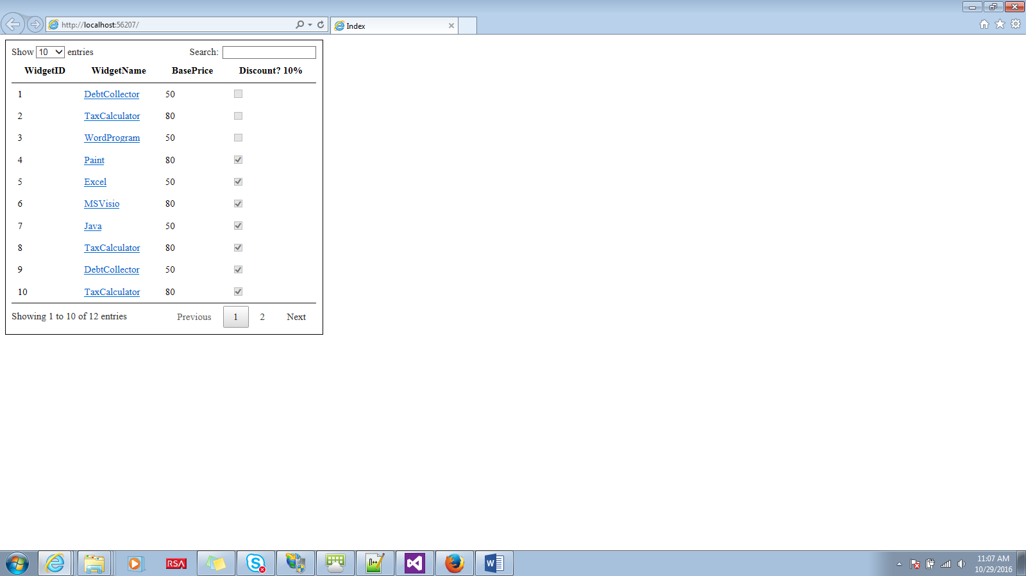

**8.Second screen**

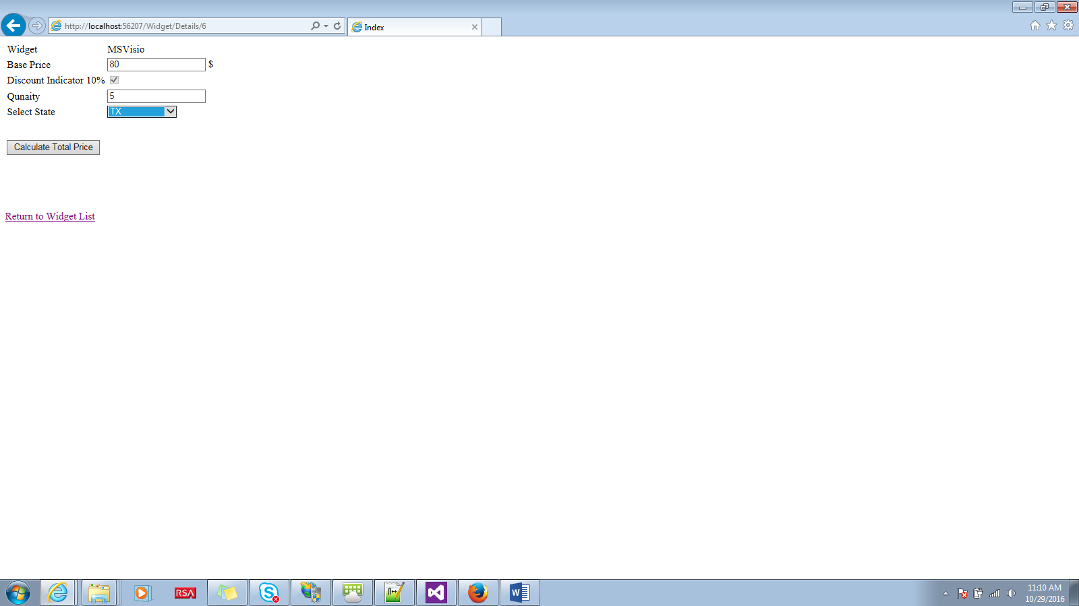

1. Third screen

